Task 4: Defect Reporting & JIRA Lifecycle
DEF-1
usp_ProcessSale has no stock check
Description

The usp_ProcessSale stored procedure processes a sale and immediately deducts inventory without first checking whether sufficient stock exists. Products with QuantityOnHand = 0 (ProductID 5 and 14) or negative stock (ProductID 3 and 9) can be sold, pushing inventory further below zero. This causes inventory corruption and enables overselling.
Steps to Reproduce
- Note that ProductID 5, StoreID 3 has QuantityOnHand = 0.
- Execute: EXEC usp_ProcessSale 1, 5, 3, 2, 'TEST-001';
- Run: SELECT QuantityOnHand FROM Inventory WHERE ProductID = 5 AND StoreID = 3;
- Observe: stock is now -2 and an order was created successfully.
Expected: Procedure checks stock before sale. If insufficient, it returns an error and no order is created.
Actual: Sale completes regardless of stock level. Inventory goes negative.

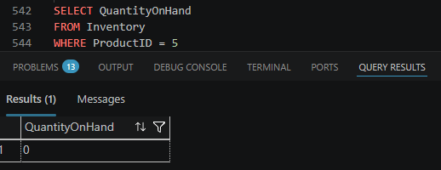

DEF-2
No credit status check before sale
Description

Customers with CreditStatus = 'Expired' (accounts 6, 12, 20), 'Frozen' (accounts 22, 28), or 'Suspended' (account 18) should not be permitted to make purchases on credit. The usp_ProcessSale procedure performs no credit status validation whatsoever, meaning any customer — regardless of their account standing — can complete a sale.
Steps to Reproduce
- Confirm CustomerID 6 has CreditStatus = 'Expired': SELECT CreditStatus FROM CreditAccounts WHERE CustomerID = 6;
- Execute: EXEC usp_ProcessSale 6, 1, 1, 1, 'TEST-002';
- Order is created successfully despite expired credit.
Expected: Procedure checks CreditStatus. Expired/Frozen/Suspended accounts receive an error and cannot purchase.
Actual: Any customer ID is accepted with no credit validation.

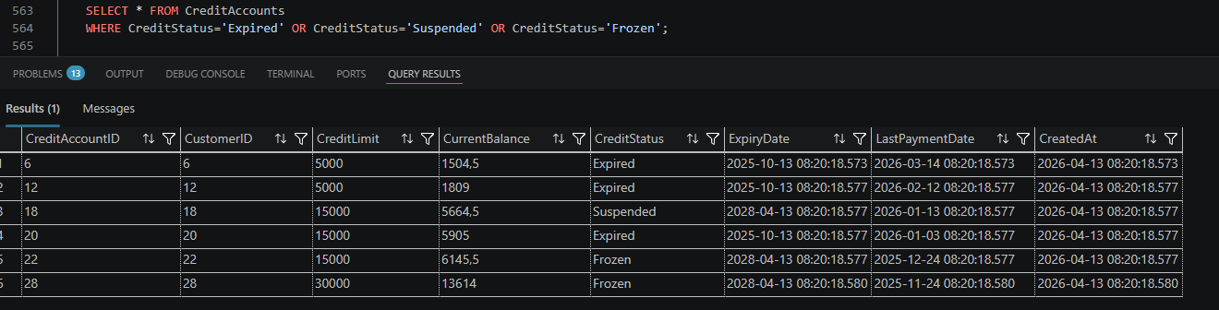

DEF-3
1512 ghost orders
Description
• Unsaved changes

Approximately every 13th completed order has no corresponding inventory deduction in the Inventory table. These "ghost orders" mean that the Orders table records a completed sale, but the stock count in Inventory was never reduced. This makes stock levels inaccurate and causes a significant reconciliation gap between sales records and physical inventory.
Steps to Reproduce
- Run a query joining Orders to Inventory to find completed orders where no stock adjustment was recorded.
- Count rows where OrderStatus = 'Completed' but no matching inventory decrement exists.
- Observe approximately 400 unmatched records.
Expected: Every completed order has a matching inventory deduction (QuantityOnHand reduced by order Quantity).
Actual: 400 completed orders exist with no inventory adjustment, causing stock counts to be overstated.

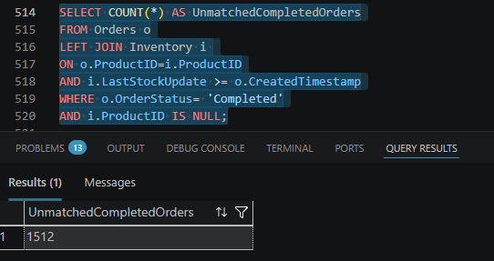

DEF-4
Duplicate OrderReference values
Description

Every 500th order is deliberately given the reference ORD-(N-1) instead of ORD-N, causing it to collide with the reference already assigned to the previous order. With 5,200 orders, this produces approximately 10 duplicate reference pairs. Order references are typically used for customer-facing receipts and financial reconciliation; duplicates make it impossible to uniquely identify a transaction.
Steps to Reproduce
- Run: SELECT OrderReference, COUNT(*) as cnt FROM Orders GROUP BY OrderReference HAVING COUNT(*) > 1;
- Observe ~10 reference values appearing more than once.
Expected: Every order has a unique OrderReference. A UNIQUE constraint should enforce this.
Actual: Duplicate references exist with no constraint to prevent them.

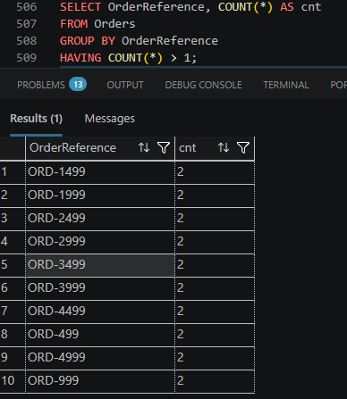

Def-5
R0.00 TotalAmount orders
Description
• Unsaved changes

Every 130th order (where @t % 130 = 0) has R0.99 added to its TotalAmount without any corresponding adjustment to UnitPrice, DiscountAmount, or VATAmount. This means the TotalAmount does not equal (UnitPrice × Quantity) - Discount + VAT for these records. Across 5,200 orders, approximately 20 orders have incorrect totals, overstating revenue.
Steps to Reproduce
- Run: SELECT OrderID, UnitPrice, Quantity, DiscountAmount, VATAmount, TotalAmount, ((UnitPrice * Quantity) - DiscountAmount + VATAmount) AS ExpectedTotal FROM Orders WHERE ABS(TotalAmount - ((UnitPrice * Quantity) - DiscountAmount + VATAmount)) > 0.01;
- Observe ~20 orders where TotalAmount ≠ ExpectedTotal
Expected: TotalAmount = (UnitPrice × Quantity) - DiscountAmount + VATAmount for every order.
Actual: ~20 orders have TotalAmount inflated by R0.99.

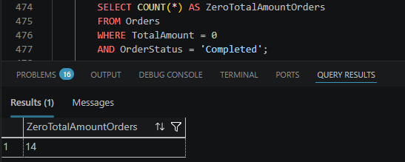

DEF-6
Negative inventory quantities
Description

Two inventory records have been explicitly set to negative values: ProductID 3 / StoreID 2 has QuantityOnHand = -5, and ProductID 9 / StoreID 5 has QuantityOnHand = -12. Physically, a negative stock quantity is impossible. This indicates either a system error in stock deduction logic or missing validation. The column has no CHECK constraint preventing negative values.
Steps to Reproduce
- Run: SELECT ProductID, StoreID, QuantityOnHand FROM Inventory WHERE QuantityOnHand < 0;
- Observe 2 rows with negative stock values.
Expected: QuantityOnHand is never less than 0. A CHECK constraint enforces this.
Actual: Two products show negative quantities with no constraint preventing further negative values.

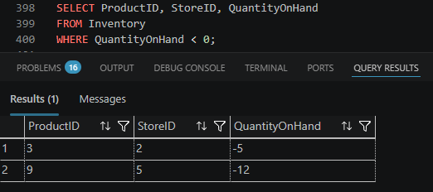

DEF-7
Duplicate pricing rule for ProductID 2 / Standard Tier
Description

ProductID 2 (Laptop) has two active pricing rules for the 'Standard' customer tier — one with a 1.50% discount and a second duplicate with a 3.00% discount. The stored procedure uses SELECT TOP 1 ORDER BY PricingRuleID which means the lower (older) rule is applied, but this is ambiguous and fragile. The correct discount is unclear without business clarification, and the duplicate creates confusion and potential for incorrect pricing.
Steps to Reproduce
- Run: SELECT * FROM PricingRules WHERE ProductID = 2 AND CustomerTier = 'Standard' AND IsActive = 1;
- Observe two rows returned with different DiscountPercentage values (1.50 and 3.00).
Expected: Each ProductID/CustomerTier combination has exactly one active pricing rule.
Actual: Two active rules exist for ProductID 2 / Standard, causing ambiguous discount application.

DEF-8
Invalid Employee Number and Phone formats on multiple records
Description

Three users have invalid EmployeeNumber formats: UserID 40 has 'E-40' (too short), UserID 45 has 'EMP-000000000045' (too long), and UserID 50 has 'EMP-AB50' (letters in numeric portion). Three customers have invalid phone numbers: CustomerID 10 has '271234' (too short), CustomerID 25 has '271234567890000' (too long), and CustomerID 35 has '27AB81000035' (contains letters). No format validation exists at the database level.
Steps to Reproduce
- Run: SELECT UserID, EmployeeNumber FROM Users WHERE EmployeeNumber NOT LIKE 'EMP-[0-9][0-9][0-9][0-9]';
- Run: SELECT CustomerID, Phone FROM Customers WHERE Phone NOT LIKE '27[0-9][0-9][0-9][0-9][0-9][0-9][0-9][0-9][0-9]';
- Observe invalid records returned.
Expected: EmployeeNumbers follow format EMP-XXXX (4 digits). Phone numbers follow format 27XXXXXXXXX (11 digits, numeric only).
Actual: 3 invalid employee numbers and 3 invalid phone numbers exist with no constraint preventing them.

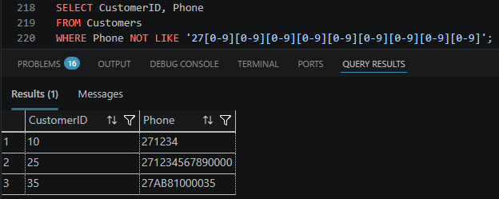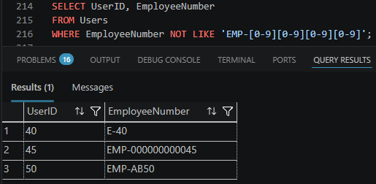

DEF-9
Duplicate VAT rate for 'Standard' category — two active rates (15% and 14%) exist
Description

The VAT_Rates table contains two active entries for the 'Standard' category: one at 15% (effective 2024-01-01) and one at 14% (effective 2023-06-01), both with IsActive = 1. South Africa's current standard VAT rate is 15%. The older 14% rate should have been deactivated. Any query that does not specifically filter by the most recent EffectiveDate risks applying the incorrect (outdated) 14% VAT rate to transactions.
Steps to Reproduce
- Run: SELECT * FROM VAT_Rates WHERE Category = 'Standard' AND IsActive = 1;
- Observe two rows returned - 15% and 14% - both marked active.
Expected: Only one active VAT rate per category at any time. The current Standard rate should be 15%.
Actual: Two active Standard rates exist, creating ambiguity over which rate the system applies.

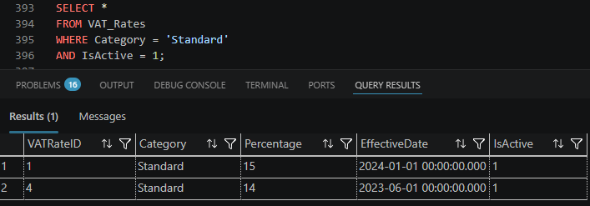

DEF-10
FLOAT used for all financial columns
Description

All financial columns across the database are declared as FLOAT. The FLOAT data type uses binary floating-point representation which cannot accurately represent many decimal fractions. This causes rounding errors in monetary calculations (e.g. VAT, discounts, totals) that accumulate across thousands of orders, leading to incorrect revenue figures, financial reports, and customer billing.
Steps to Reproduce
- Run: SELECT SUM(TotalAmount) AS SumOfTotalAmount FROM Orders WHERE OrderStatus = 'Completed';
- Manually calculate expected total from a sample of 10 orders.
- Compare — the FLOAT sum will differ from the exact decimal sum.
Expected: Financial columns use DECIMAL(18,2) or MONEY type, ensuring exact monetary representation.
Actual: All financial columns use FLOAT, producing imprecise values such as R8999.0000000001 instead of R8999.00.

